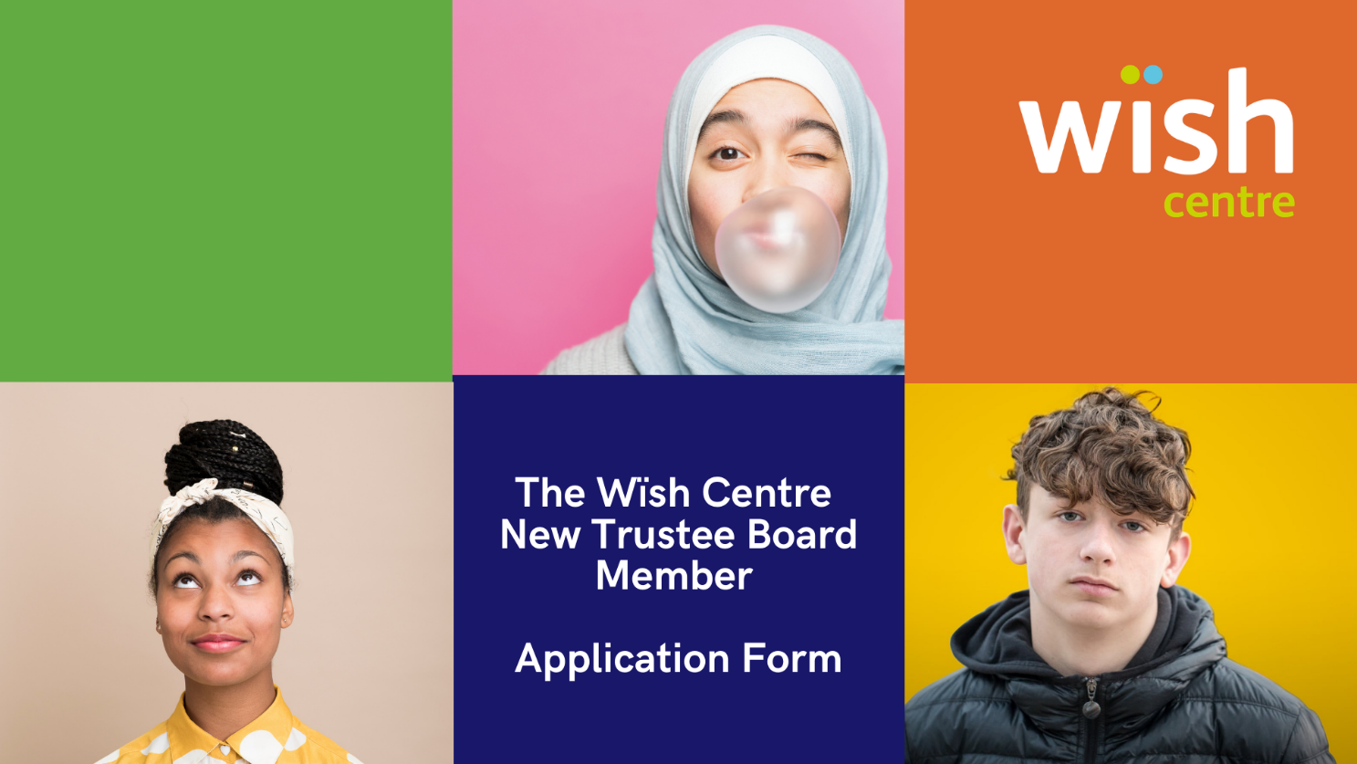

We are actively encouraging people aged 18-25 to apply for this role. Please complete this form and email to info@thewishcentre.org.uk Deadline 27th January. If you are shortlisted there will be a digital interview.

Forename/s
Surname
Gender/Pronouns
Home Address

Postcode
Date of Birth
Mobile
Email
Ethnicity
Work Title/Position
Organisation
Qualifications & Training

Why do you want to be a Trustee of WISH?

We want a trustee board that are passionate about the issues that young people are facing in 2021 and lived experience is invaluable to us. Please use this space to tell us any lived experiences you have that may be relevant to the work that we do at WISH e.g. mental health, self harm, CSE :

Please outline any other knowledge, skills and experience you bring:

As a small charity, we are always looking for new ways to fund and raise awareness about the issues and our services for young people. Tell us about your fundraising and campaigning experience:

For the time being this will mainly be a digital role, please let us know of any access needs you may have:

Declaration
I declare that:

- I do not have an unspent conviction relating to any offence involving deception or dishonesty
- I am not an undischarged bankrupt
- I have not entered into an Individual Voluntary Arrangement which has not been discharged
- I am not under a disqualification order under the Company Directors’ Disqualification Act 1986
- I have not previously been removed from trusteeship of a charity by a Court or the Charity Commission
- I commit to attending four meetings a year, plus the Annual Strategic Retreat and other meetings/trainings as required
- I agree to undergo Safeguarding Training and Enhanced DBS checks

I declare that the information I have given in support of my application is true and correct. I agree to the wïsh centre carrying out a DBS check and that all information relating to the wïsh centre will be confidential and will sign confidentiality and conflict of interest contracts

Signature________________________ Date____________

Thank you. This information is confidential and for legal purposes only.

