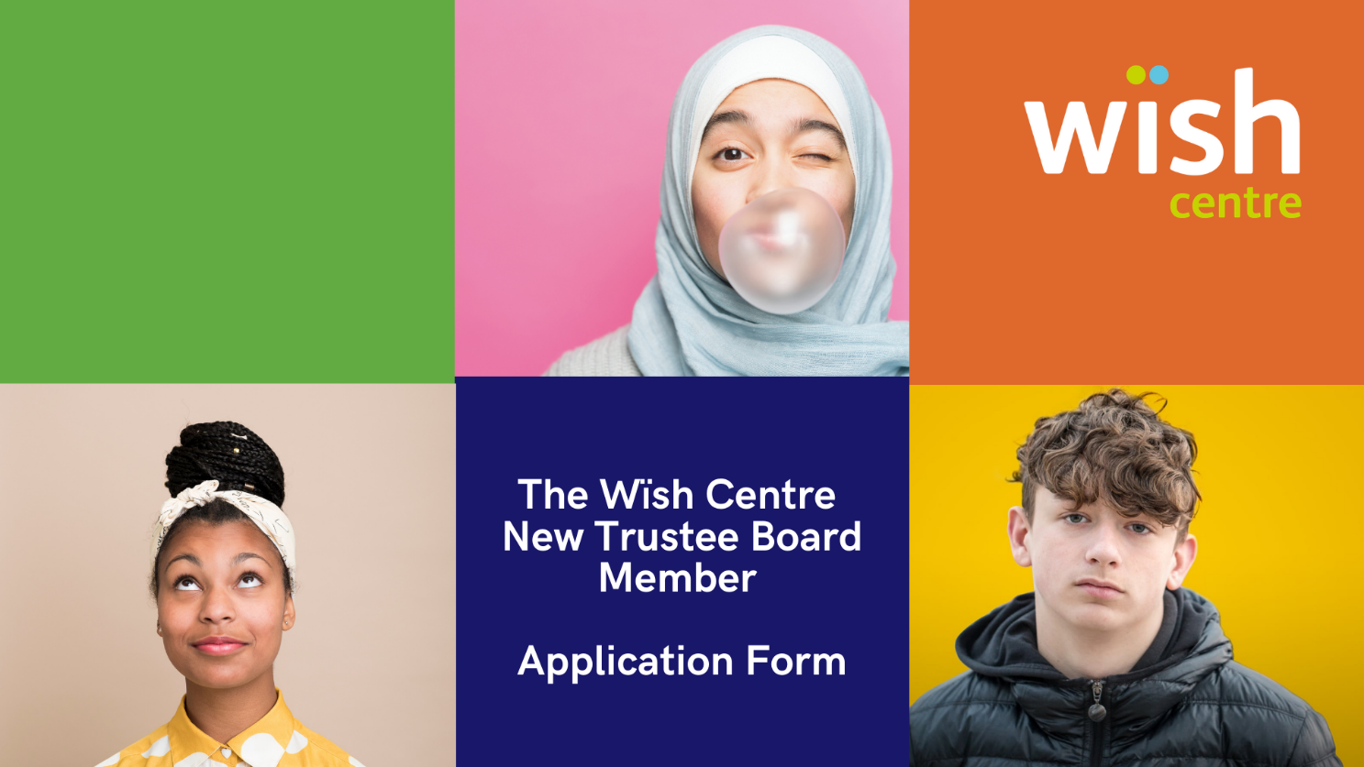

First name
Surname
Gender/Pronouns
Mobile
Email

What do you know about the wïsh centre and why do you want to be a Trustee?

What ideas, skills and experience can you bring to help us provide the best services possible to children and young people in Harrow, including local knowledge?

As a small charity, we are always looking for new ways to raise awareness. Please tell us about any fundraising, social media or campaigning experience:

Our meetings are usually in person every quarter. Please let us know of any access needs you may have:

Declaration
I declare that:

- I do not have an unspent conviction relating to any offence involving deception or dishonesty
- I am not an undischarged bankrupt
- I have not entered into an Individual Voluntary Arrangement which has not been discharged
- I am not under a disqualification order under the Company Directors’ Disqualification Act 1986
- I have not previously been removed from trusteeship of a charity by a Court or the Charity Commission
- I commit to attending four meetings a year, plus the Annual Strategic Retreat and other meetings/trainings as required
- I agree to undergo Safeguarding Training and Enhanced DBS checks

I declare that the information I have given in support of my application is true and correct. I agree to the wïsh centre carrying out a DBS check and that all information relating to the wïsh centre will be confidential and will sign confidentiality and conflict of interest contracts

Signature ______________________ Date _______________

This information is confidential and for legal purposes only.

Please email completed forms to info@thewishcentre.com

